Harbour Rose Boutique Wireframes

[https://wireframe.cc/vssNfe- Home page 1](https://wireframe.cc/vssNfe-%20Home%20page%201)

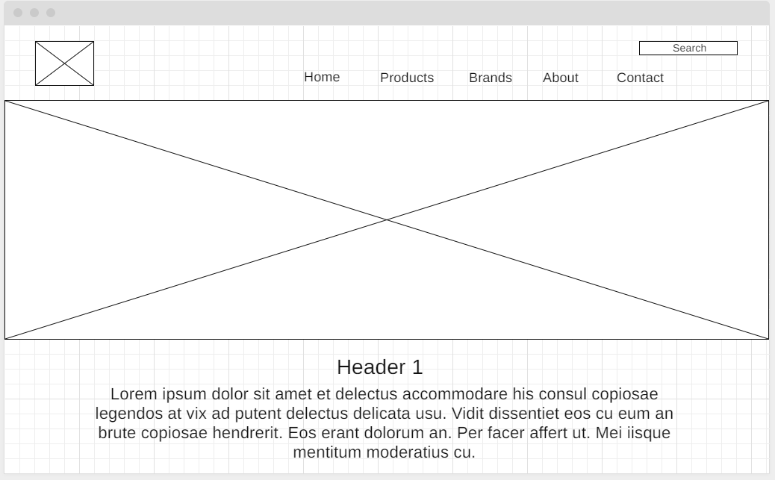

[https://wireframe.cc/vssNfe - Home page 2](https://wireframe.cc/vssNfe%20-%20Home%20page%202)

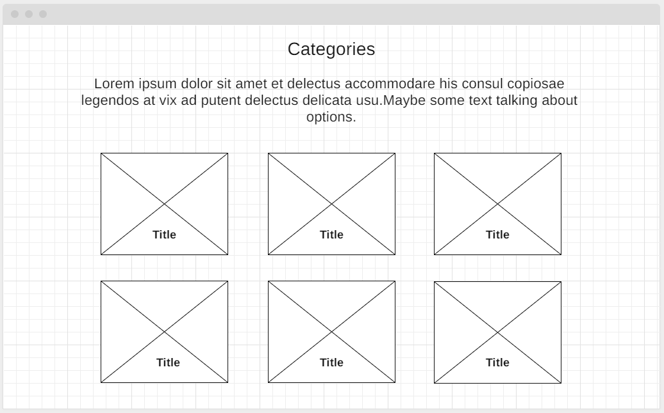

[https://wireframe.cc/p544vG - home page 3](https://wireframe.cc/p544vG%20-%20home%20page%203)

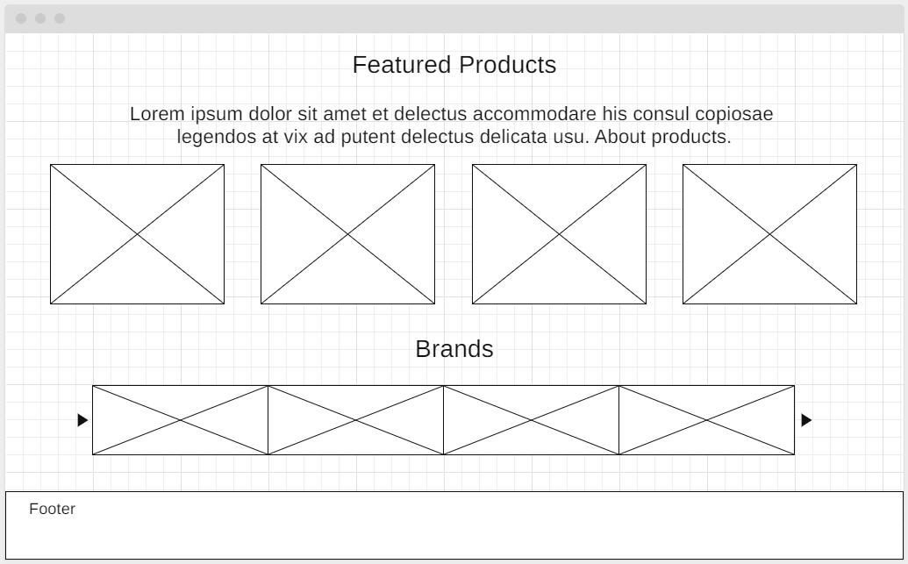

<https://wireframe.cc/2CVyzJ> - products page

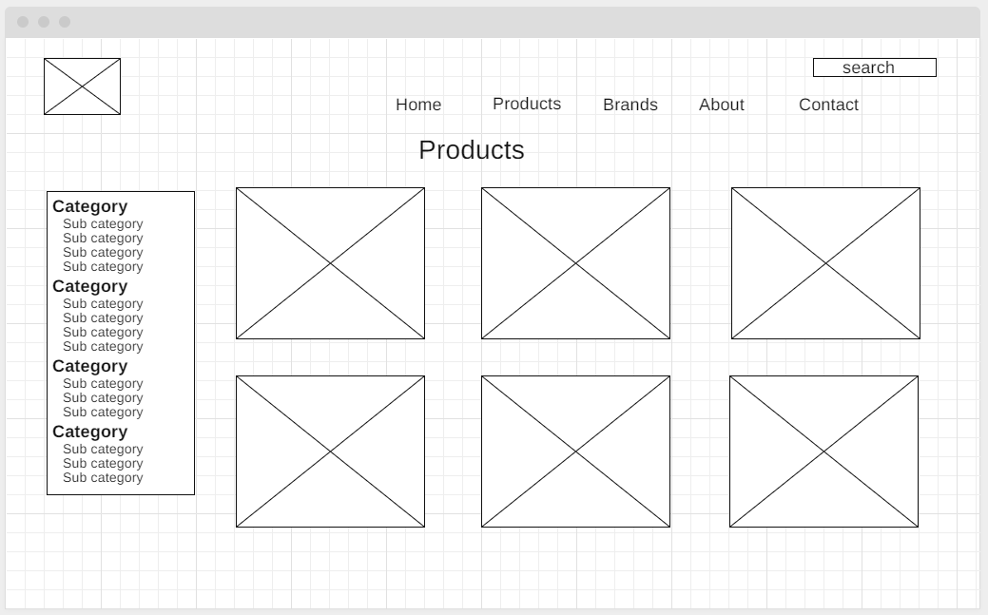

<https://wireframe.cc/JU0ru2> -brand page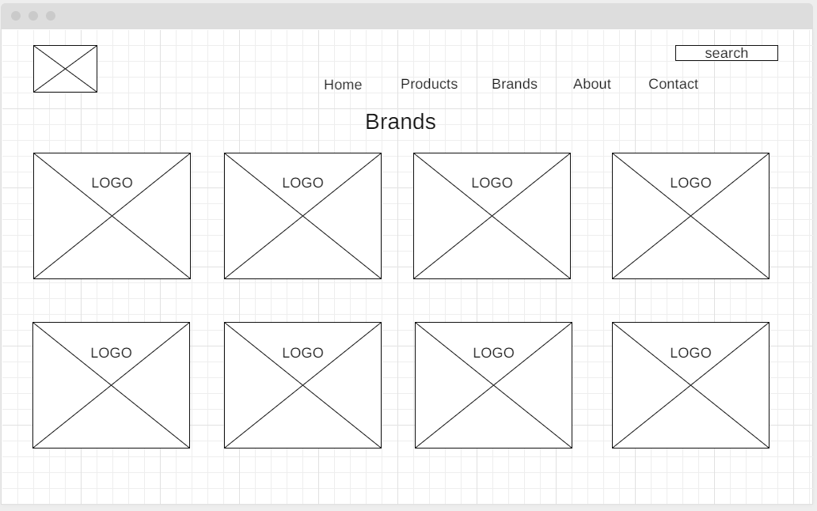

About page

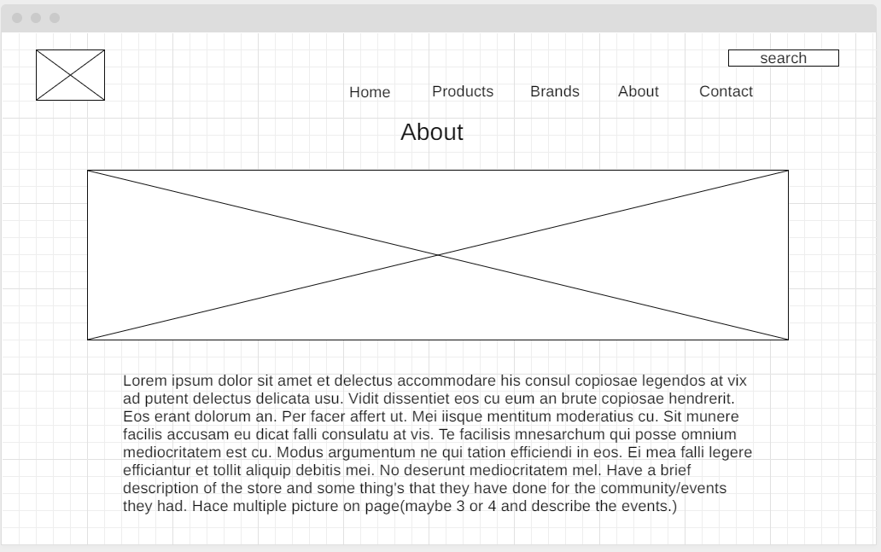

Contact page

